2020 DSE MC

1. 
2. .
3. .
4. .
5. .
6. If , then 
7. .
8. .
9. .
10. .
11. 
12. .
13. .
14. .
15. .
16. 
17. .
18. .
19. .
20. .
21. Let . If  is a constant, then 
22. .
23. .
24. .
25. .
26. Let , where  is a constant. If  is a factor of , then 
27. .
28. .
29. .
30. .
31. If  and  are constants such that , then 
32. .
33. .
34. .
35. .

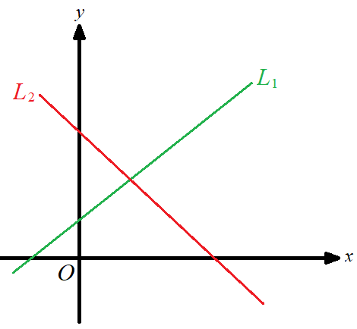

1. In the figure, the equations of the straight lines  and  are 

and  respectively.Which of the following are true?

1. 
2. 
3. 
4. I and II only
5. I and III only
6. II and III only
7. I, II and III
8. The cost of a toy is  lower than its selling price. After selling the toy, the percentage profit is 25%.

Find .

1. 
2. 
3. 
4. 
5. The actual area of a golf course is 0.75 km 2 . If the area of the course on a map is 300 cm 2 , then the scale of the map is
6. .
7. .
8. .
9. .
10. It is given that  varies as the cube of  and the square root of . When  and , .

When  and , 

1. .
2. .
3. .
4. .
5. In the figure, the 1st pattern consists of  dots. For any positive integer  , the th pattern is formed by adding

 dots to the *n* th pattern. Find the number of dots in the 7th pattern.



1. 15
2. 27
3. 38
4. 51
5. The solution of  and  is
6. .
7. .
8. .
9. .

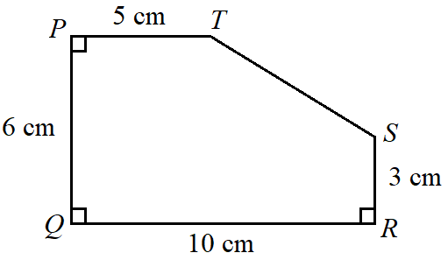

1. In the figure,  is a pentagon, where all the measurements are

correct to the nearest cm . Let  cm 2 be the actual area of the pentagon.

Find the range of values of  .

1. 
2. 
3. 
4. 
5. The angle of a sector is decreased by  but its radius is increased by . If the arc length of the sector

remains unchanged, find the value of .

1. 40
2. 60
3. 67
4. 150
5. If the volume of a right circular cylinder of base radius  cm and height  cm is  cm3 , then the volume of

a right circular cone of base radius  cm and height  cm is

1. 175 cm3 .
2. 245 cm3 .
3. 490 cm3 .
4. 735 cm3 .

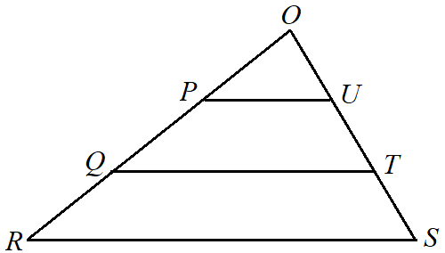

1. In the figure,  and  are points lying on  while  and  are

points lying on  such that and . The ratio

of the area of the trapezium  to the area of the trapezium  is

1. 1 : 2 .
2. 2 : 3 .
3. 3 : 5 .
4. 4 : 9 .

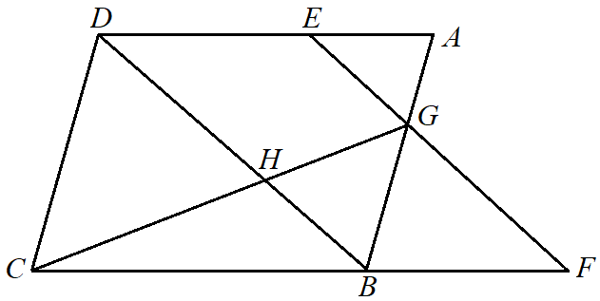

1. In the figure,  is a parallelogram. Let  be a point lying on 

such that  .  is produced to the point  such that

 . Denote the point of intersection of  and  by .

It is given that  and  intersect at the point . If the area of

 is 48 cm2, then the area of  is

1. 98 cm2 .
2. 343 cm2 .
3. 420 cm2 .
4. 588 cm2 .

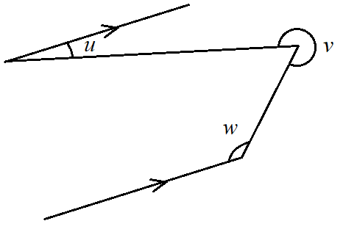

1. According to the figure, which of the following must be true?
2. 
3. 
4. 
5. I only
6. II only
7. I and III only
8. II and III only
9. In the figure,  is an equilateral triangle and  is an isosceles

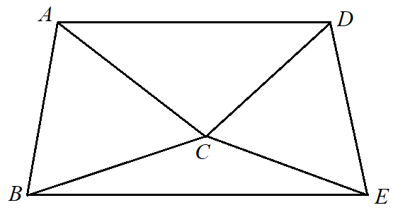

triangle with . If  and ,

then 

1. .
2. .
3. .
4. .

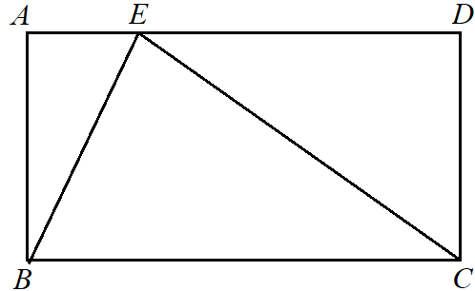

1. In the figure,  is a rectangle. Let  be a point lying on 

such that  cm and  cm. If  cm, find the

area of the rectangle .

1. 60 cm2
2. 68 cm2
3. 120 cm2
4. 136 cm2

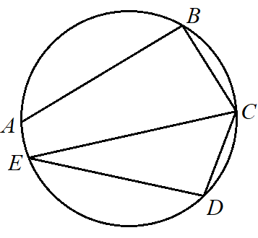

1. In the figure,  is a circle. If  cm,  cm,

 and , find  correct to the nearest cm.

1. 5 cm
2. 6 cm
3. 7 cm
4. 8 cm
5. A ship is 50 km due west of a lighthouse. If the ship moves in the direction , find the shortest distance

between the ship and the lighthouse.

1. 20 km
2. 25 km
3. 43 km
4. 87 km
5. The point  is translated leftwards by 4 units to the point . If the coordinates of the reflection image of 

with respect to the *y*-axis are , then the polar coordinates of  are

1. .
2. .
3. .
4. .
5. Let  be the point of intersection of the straight line  and . If  is a moving

point in the rectangular coordinate plane such that the distance between  and  is 8, then the locus of  is a

1. circle.
2. triangle.
3. quadrilateral.
4. regular hexagon.
5. The equation of the straight line  is , where  is a constant. If  is perpendicular to the

straight line , find the *y*-intercept of .

1. 
2. 
3. 
4. 
5. The equations of the circles  and  are  and 

respectively. Which of the following is/are true?

1. The centre of  lies on .
2. The radii of  and  are equal.
3.  and  intersect at two distinct points.
4. I only
5. II only
6. I and III only
7. II and III only
8. Two numbers are randomly drawn at the same time from four cards numbered , ,  and  respectively.

Find the probability that the product of the numbers drawn is greater than .

1. 
2. 
3. 
4. 
5. The bar chart on the right shows the distribution of the numbers

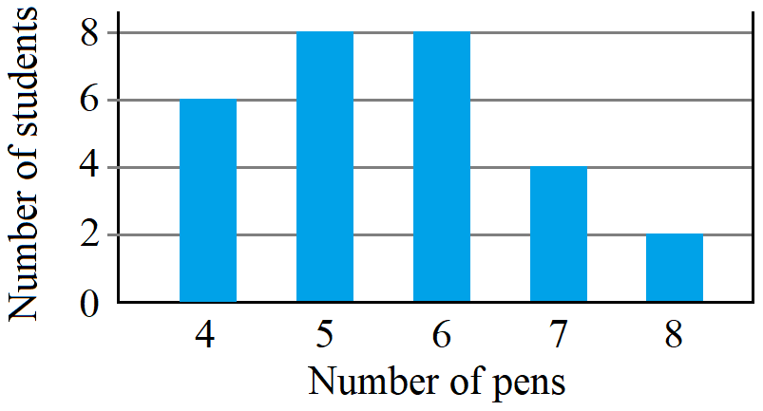

of pens owned by some students. Find the inter-quartile range

of the distribution.

1. 1
2. 2
3. 4
4. 6
5. Consider the following integers:
6. 3 8 8 8 10 12 *m* *n*

Let ,  and  be the median, the mean and the mode of the above integers respectively. If the range of the above

integers is 9, which of the following must be true?

1. 
2. 
3. 
4. I only
5. II only
6. I and III only
7. II and III only

**Section B**

1. B00000000000003016 =
2. .
3. .
4. .
5. .
6. If the roots of the equation  are  and , then 
7. .
8. .
9. .
10. .
11. The figure shows the graph of  and the graph of  on

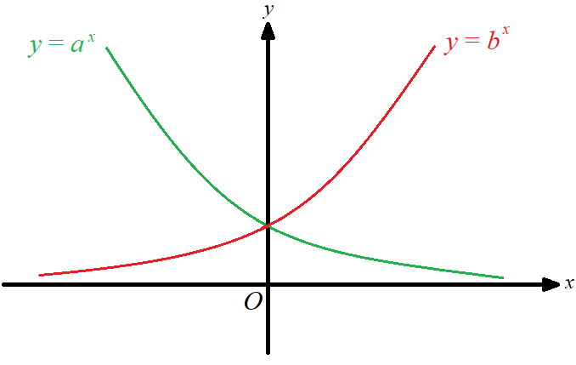

the same rectangular coordinate system, where  and  are positive

constants. If the graph of  is the reflection image of the graph

of  with respect to the *y*-axis, which of the following are true?

1. 
2. 
3. 
4. I and II only
5. I and III only
6. II and III only
7. I, II and III

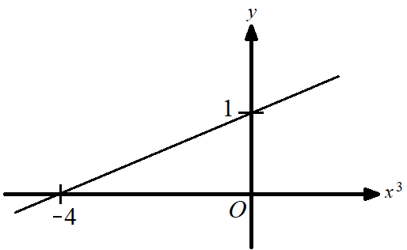

1. The graph in the figure shows the linear relation between  and .

If , then 

1. 3 .
2. 8 .
3. 9 .
4. 33 .
5. If , which of the following are arithmetic sequences?
6. , , 
7. , , 
8. , , 
9. I and II only
10. I and III only
11. II and III only
12. I, II and III
13. Consider the following system of inequalities:



Let  be the region which represents the solution of the above system of inequalities. Find the constant 

such that the least value of  is 24, where  is a point lying in .

1. 25
2. 27
3. 37
4. 53
5. Define  and , where  is a real number. If the imaginary part of  is equal to the

imaginary part of , then 

1. .
2. 0 .
3. 3 .
4. 10 .

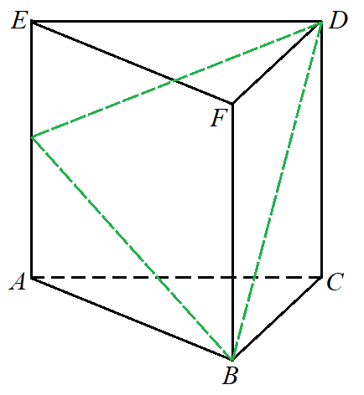

1. In the figure,  is a right triangular prism.  is a point lying on

. If cm, cm, cm and cm, find

the area of .

1.  cm
2.  cm
3.  cm
4.  cm
5. In the figure,  and  are circles such that  is a straight

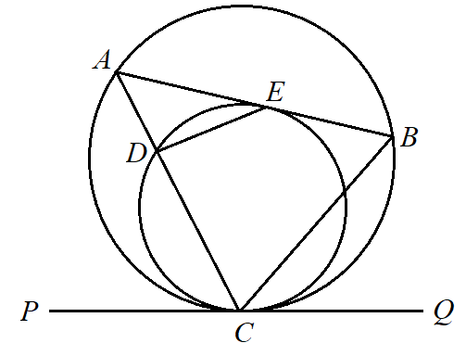

line.  is the common tangent to the two circles at .  is the

tangent to the circle  at . If  and ,

then 

1. 
2. 
3. 
4. 
5. The equations of the three sides of a triangle are ,  and , where  is a constant.

If the *x*-coordinate of the in-centre of the triangle is  , then 

1. 15 .
2. 31 .
3. 45 .
4. 51 .
5. Find the range of values of  such that the circle  and the straight line  intersect.
6. 
7. 
8.  or 
9.  or 
10. A queue is formed by 6 boys and 5 girls. If no boys are next to each other, how many different queues can be formed?
11. 86 400
12. 172 800
13. 213 444
14. 39 916 800
15. There are  Chinese books and  English books in a box. If  books are randomly chosen from the box at

the same time, find the probability that at most  Chinese books are chosen.

1. 
2. 
3. 
4. 
5. In a test, the difference of the test scores and the difference of the standard scores of two students are 30 marks and

 respectively. In the test, the standard deviation of the test scores is

1. 5 marks.
2. 24 marks.
3. 25 marks.
4. 36 marks.
5. The variance of the six numbers , , , ,  and  is
6. .
7. .
8. .
9. .

MC Answers

CCAAB DCAAB ADDBD

BCBBD CCBDA DCBAA

BBDCD CCAAD DABAC

8/8/7/7 + 4/3/4/4 = 12/11/11/11